**18CSC303J – DATABASE MANAGEMENT SYSTEMS**

**MINI PROJECT**

**Title of the project:**

**Trip Management System**

**Team Members:**

**RA1911003011039 - D.Md.Taha Ansari**

**RA1911003011043 - C.Ramnath Reddy**

**RA1911003011044 - S.Md.Khaja Firoz**

**SCREENSHOTS:**

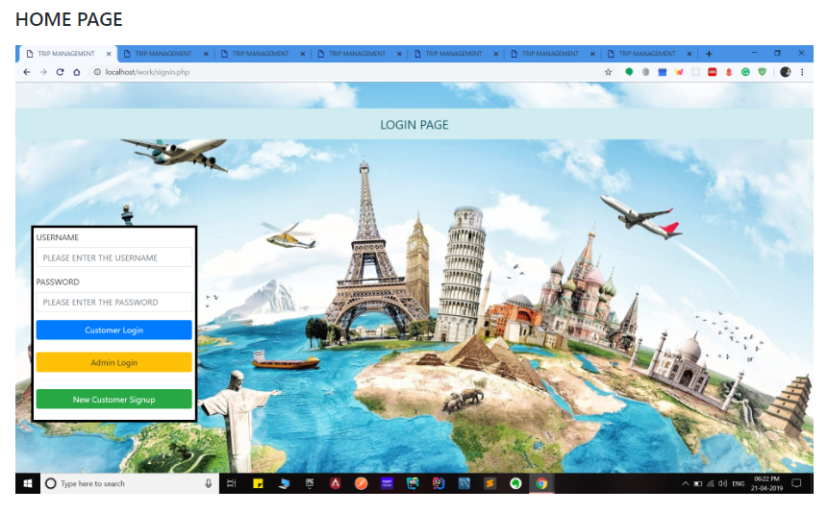

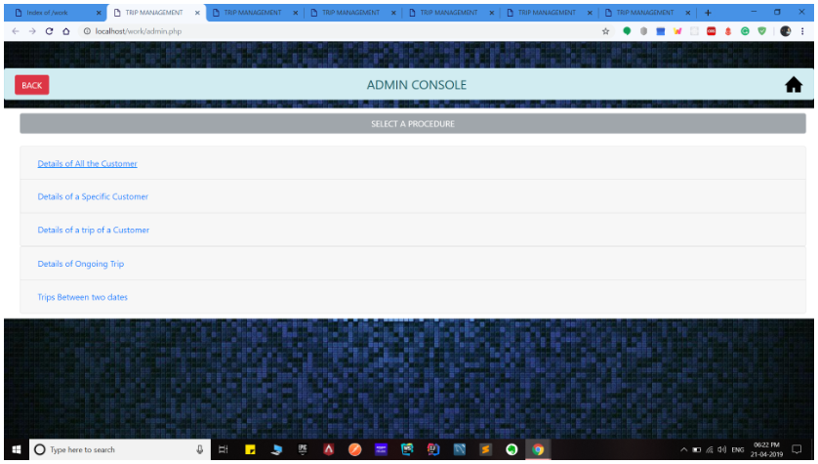

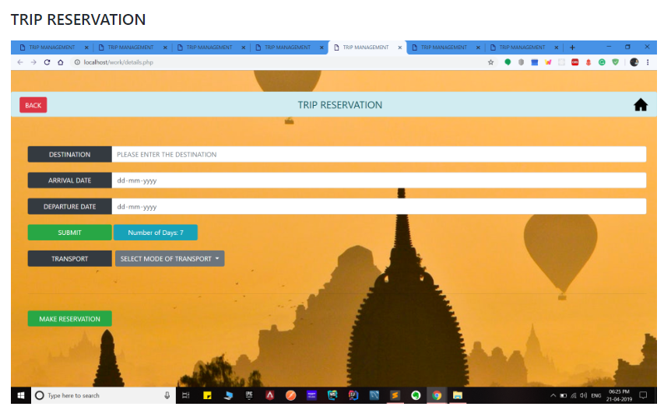

This application is develop to provide best travelling services to the customers and travel agents. We have developed tours and travel management system to provide a search platform where a tourist can find their tour places according to their choices. This system also helps to promote responsible and interesting tourism so that people can enjoy their holidays at their favorable places. This system also helps to develop tourism with different cultures so that they enrich the tourism experience and build pride. We develop this system to create and promote forms of tourism that provide healthy interaction opportunities for tourists and locals and increase better understanding of different cultures, customs, lifestyles, traditional knowledge and believes. This system also provide a better way to connect with various events.

This system also gives tours related information like which places are tourist attractions, cities, and provinces. Tourist can also get the Map and navigation system and temperature and weather information. Tourist can also book tours through our tours and travels management system. This system also keeps a history of visited places of its users.